Lab 7 observations

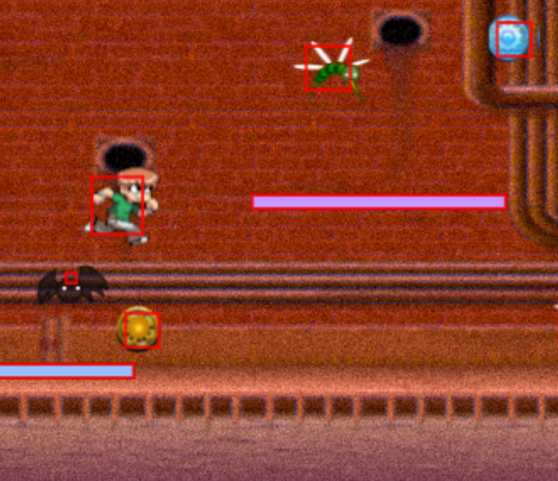
No matter how I change the hitbox of the bat or player, I cannot figure out why they are colliding with each other. I did not think making a 2d game would be this complicated compared to how much easier it is to make a game with unity or roblox studio

